# Lab: DOM

Problems for exercises and homework for the "[Free JS for Front-End Course @ SoftUni](https://softuni.bg/trainings/2946/js-for-front-end-march-2020)". Submit your solutions in the SoftUni judge system at <https://judge.softuni.bg/Contests/Practice/Index/2236#0>

## Sum Numbers

Write a function that **reads** two numbers from input fields in a **web page** and puts their **sum in another field** when the user **clicks** on a button.

|  |
| --- |
| **Sample HTML** |
| **<input type="text" id="num1" />**  **<input type="text" id="num2" />**  **<input type="text" id="sum" readonly="readonly" />**  **<input type="button" value="Calc" onclick="calc()" />**  **<script>**  **function calc() {**  **// TODO: sum = num1 + num2**  **}**  **</script>** |

### Examples

### 

## Collect List Items

Write a function that scans a given **HTML list** and **appends** all collected list items’ text to a **text area** on the same page when the user **clicks** on a button.

|  |
| --- |
| **Sample HTML** |
| **<ul id="items">**  **<li>first item</li>**  **<li>second item</li>**  **<li>third item</li>**  **</ul>**  **<textarea id="result"></textarea>**  **<br>**  **<button onclick="extractText()">Extract Text</button>**  **<script>**  **function extractText() {**  **// TODO**  **}**  **</script>** |

### Examples

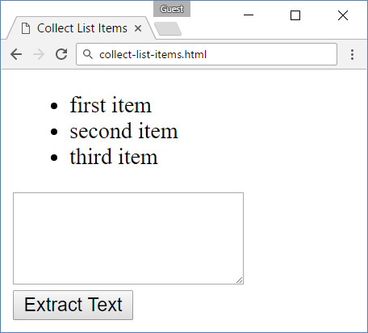 🡪 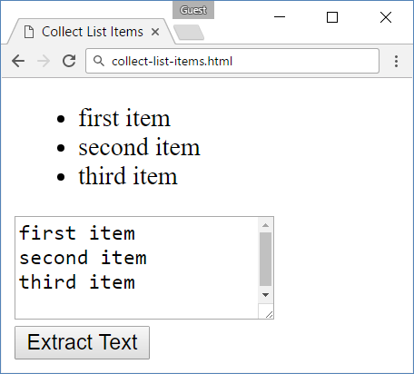

## List of Items

Write a function that **read** the text inside an input field and **appends** the specified text to a list inside an HTML page.

### Examples

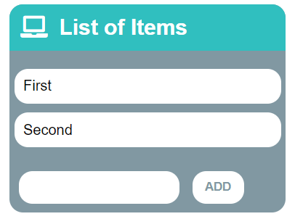🡪 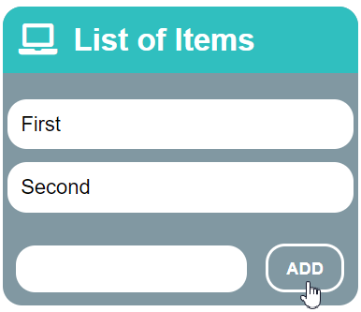🡪 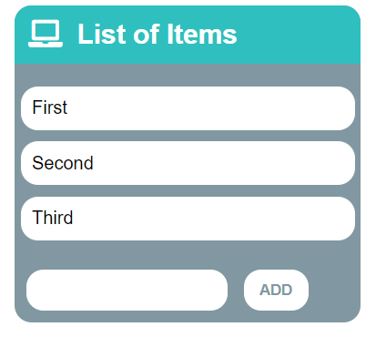

## Add / Delete

Extend the previous problem to display a **[Delete] link** after each list item. **Clicking** it, should **delete** the item with no confirmation.

### Examples

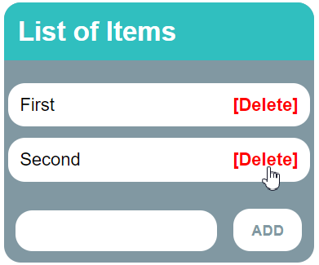🡪 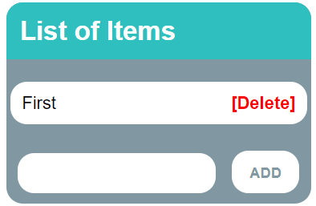

## Articles List

In this problem, you should create a functionality which creates articles and appends them into some article section.

The programs in this language are called **scripts**. They can be written right in the HTML and **executed** **automatically** as the page loads.

Scripts are provided and executed as a **plain text**. They don't need a special preparation or a compilation to run.

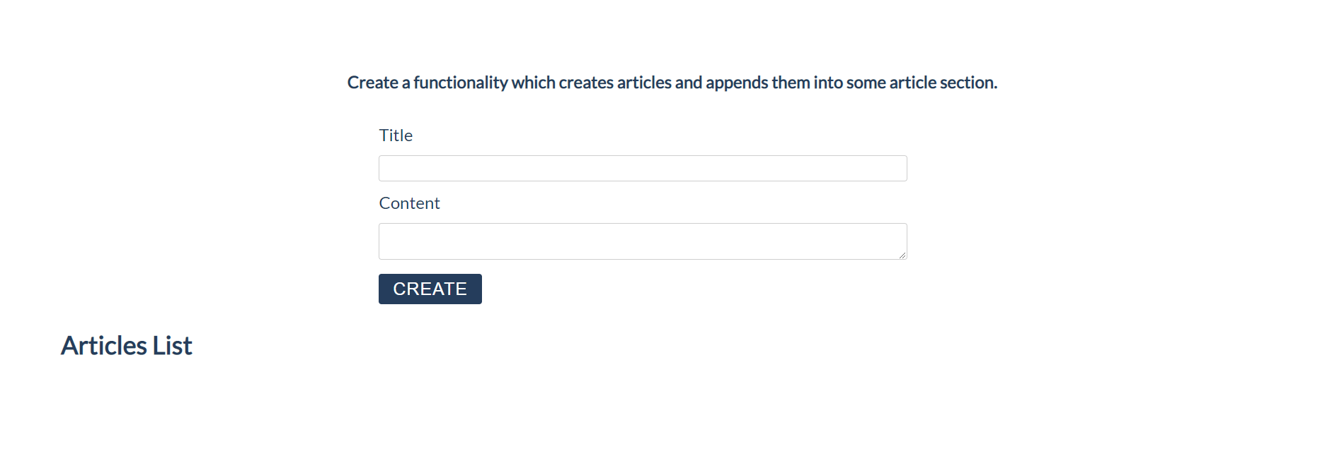

### Constraints:

* **Title value** from the **title input** should be a **heading 3 element <h3>**
* **Content text** from the textarea **element** should be a **paragraph <**p**>**
* Both new created elements (h3 and p) should be appended to a new **article element <article>**
* **The current article element** should be **appended** to the section which has an id articles (**#articles**)
* You should create new **article element** only if **title** and **content are not empty**
* After the button is pressed you must **clear** the **title value** and **text value**

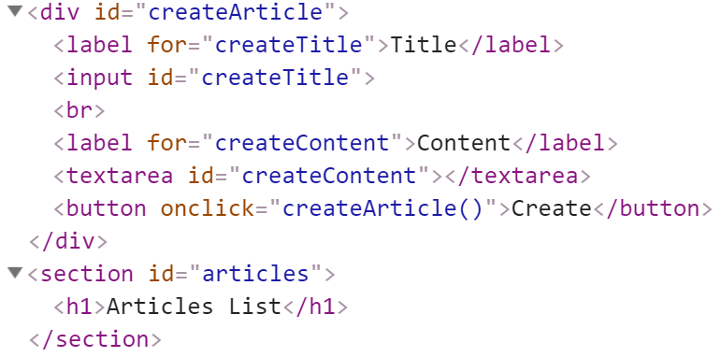

### Input:

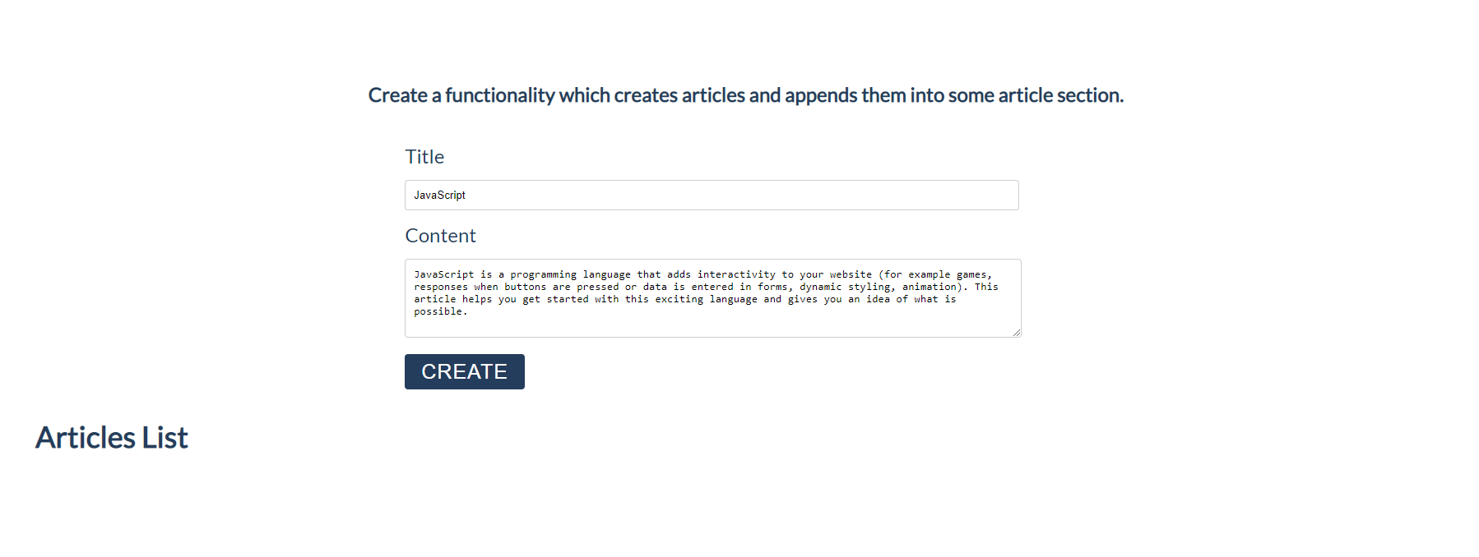

### Output:

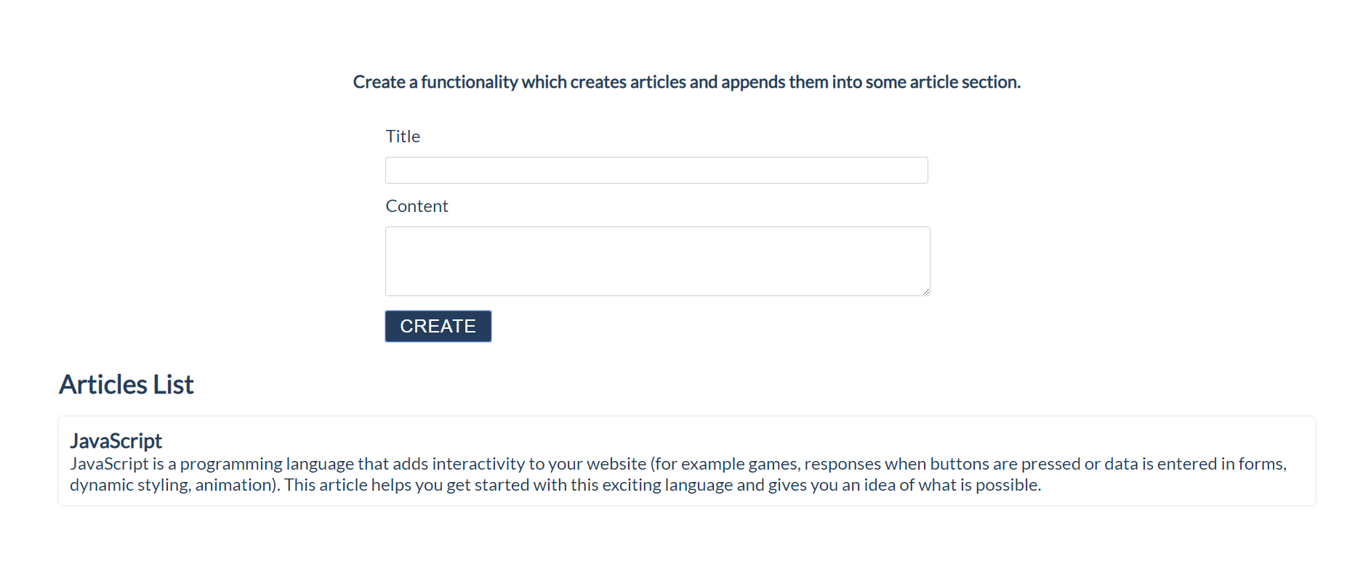

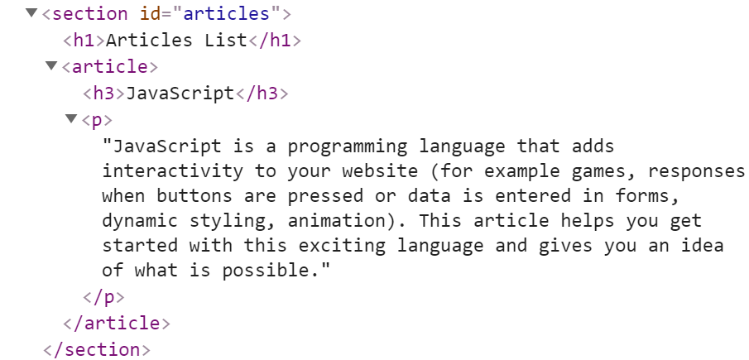

## * Format the Text

In this problem, you should **create a functionality** which **formats** the given **text** into **paragraphs.**

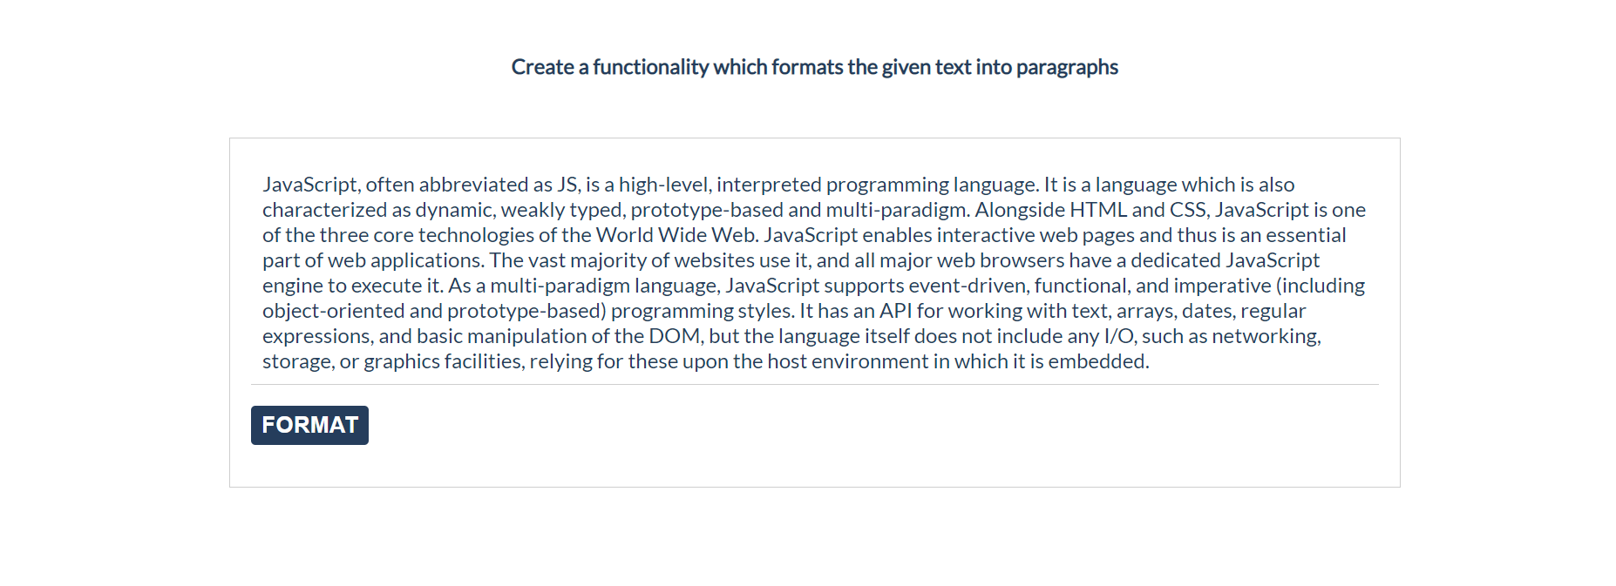

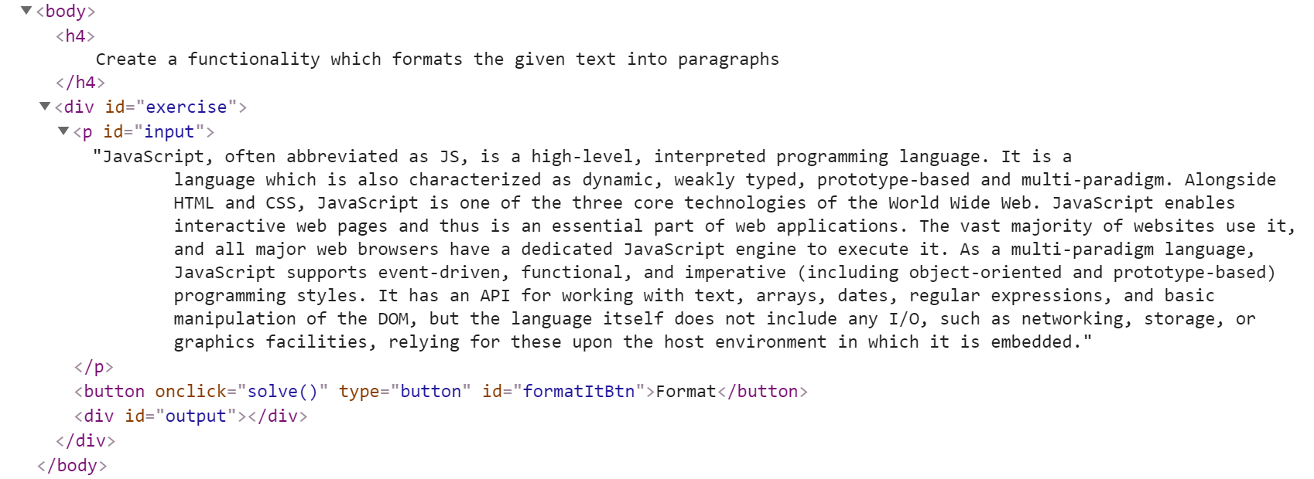

When the [**Format**] button is **clicked**, you need to **format the text** **inside** the **paragraph** with an **id**="**input**". The formatting is **done** as **follows:**

* You need to create a **new paragraph element** which holds no more than **3 sentences** from the given input**.**
* If the given input contains **less** or **3 sentences**, you need to create only 1 paragraph, fill it with these sentences and append this paragraph to the div with an **id=**"**output**".

Otherwise, when you have more than 3 sentences in that **input paragraph,** you need to create enough paragraphs to get all sentences from the **input text.**

Just remember to **restrict** the **sentences** in **each paragraph to 3.**

### Example:

* If the input paragraph **contains 2 sentences**, you need to create only **1 paragraph** with these 2 sentences
* If the input paragraph **contains 7 sentences,** you need to create **3 paragraphs**  
  - The **first paragraph** must contain **the first 3 sentences**  
  - The **second paragraph** must contain **the other three sentences** of the whole text  
  - The **third paragraph** will contain **only the last sentence**

To find out how many sentences there are in the text, simply **split** the whole text **by '.'** Also, **every sentence** must have at least **1 character.**

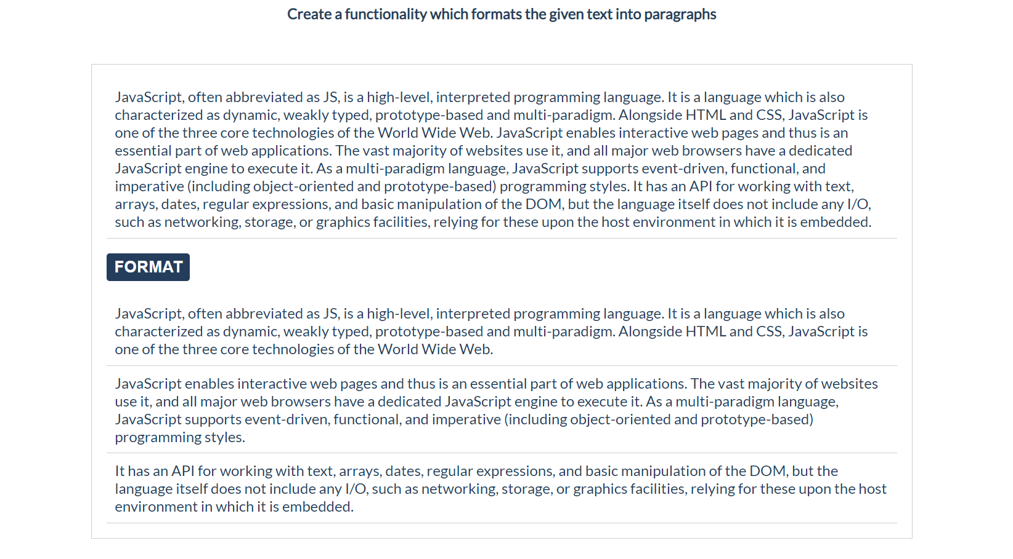

## * Visited Sites

In this problem, you should **create a functionality** that keeps track of how many times a

specific site has been **visited**.



For instance, if we click **twice** on the Gmail link and **once** on the YouTube link, the expected

result must be:

